Problem Set -01
Duration: 8 am – 4 pm.

The main objective of this day is to understand your capability in problem solving. All program must be done using Console C# application. At first, you will do the dry coding using pen and paper and after that implement your thoughts using C#.(We encourage your google search for any kind of problem solving or error fixing)
Happy problem solving

- Write hello world program in C# program.
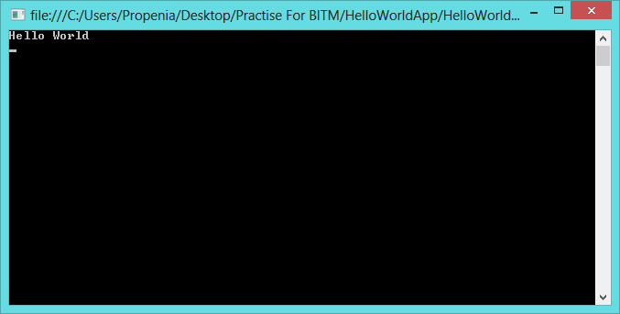
- Take two numbers from user and show their addition, subtraction, division and multiplication result in console.

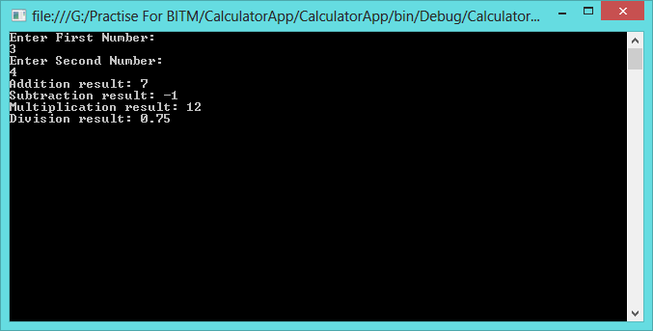

- Take two numbers from user and tell which one is bigger and which one is small. If they are equal tell that they are equal.
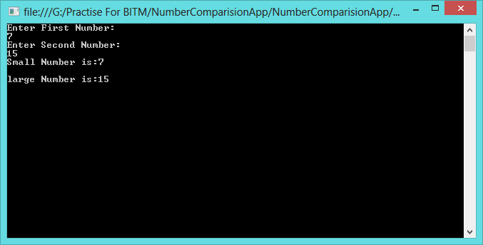
- Take user name as input and show a greeting like: Hi, <user name> good day.
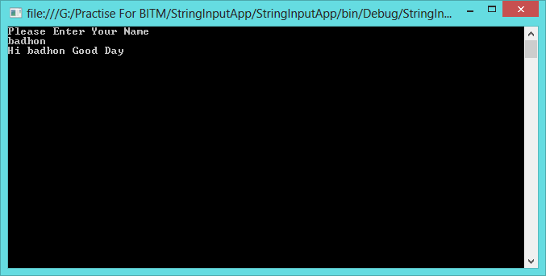

- Show number from 1 to 100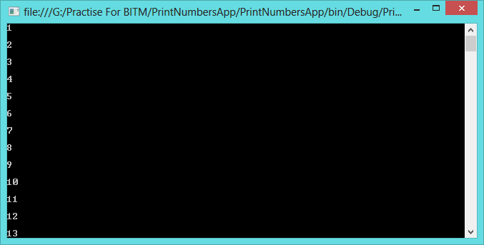
- Take upper and lower limit from user and show all integers between them (including them).
- Show all even number from 1 to 100
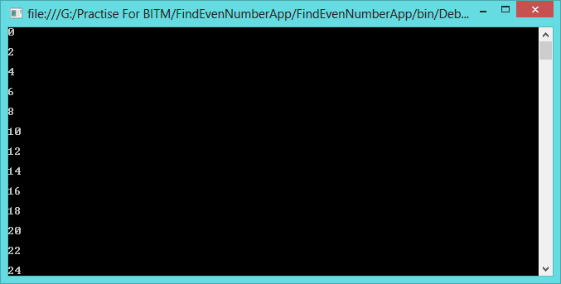
- Show first 100 Fibonacci number.
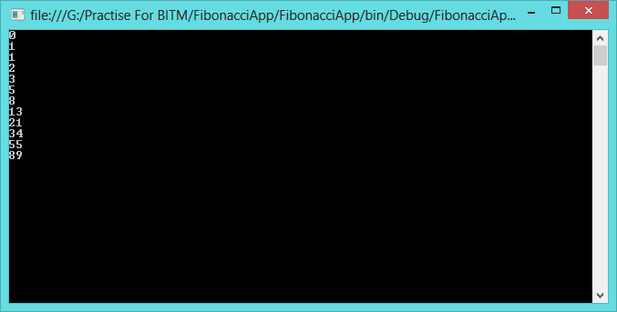
- What is windows registry? Read a show all windows registry using a C# program.
Help: i.http://en.wikipedia.org/wiki/Windows_Registry
ii. http://www.codeproject.com/Articles/3389/Read-write-and-delete-from-registry-with-C

- What is the format CSV file?
- What is environmental variable? Show all environmental variables and their value in C#.
Help:i. http://msdn.microsoft.com/en-us/library/1h5xxewc(v=vs.110).aspx
ii. http://en.wikipedia.org/wiki/Environment_variable

- What is event log in windows OS? See all event viewers in windows 8. Write a CSharp program to show eventlog in windows
- Find all services running in windows. Write a program using C# to view all the running services in your windows.
Help: http://www.csharp-examples.net/windows-service-list/

Problem_1:
namespace HelloWorldApps
{
class Program
{
static void Main(string[] args)
{
Console.WriteLine("Hello World");
Console.ReadLine();
}
}
}

PROBLEM_2:
using System;
using System.Collections.Generic;
using System.Linq;
using System.Text;
using System.Threading.Tasks;

namespace Prob1App
{
class Program
{
static void Main(string[] args)
{
Console.WriteLine("Enter number:");
float num1 = Convert.ToInt32(Console.ReadLine());
float num2 = Convert.ToInt32(Console.ReadLine());

float Add = num1 + num2;
float sub = num1 - num2;
float Div = num1 / num2;
float Mult = num1 * num2;

Console.WriteLine("Addition:" + Add);
Console.WriteLine("Division:" + Div);
Console.WriteLine("Substraction:" + sub);
Console.WriteLine("Multification:" + Mult);
Console.ReadKey();

}
}
}

Problem_3:
namespace Problem3App
{
class Program
{
static void Main(string[] args)
{ Console.WriteLine("Enter number:");
int num1 = Convert.ToInt32(Console.ReadLine());
int num2 = Convert.ToInt32(Console.ReadLine());
if (num1 == num2)
{
Console.WriteLine("Numbers are equal");

}
else if (num1 > num2)

{
Console.WriteLine("num1:" +num1);
Console.WriteLine("num2:" + num2);
Console.WriteLine("num1 is bigger than num2");
}
else
{
Console.WriteLine("num1:" + num1);
Console.WriteLine("num2:" + num2);
Console.WriteLine("num2 is bigger than num1");

}
Console.ReadKey();
}
}
}

Problem_4:
amespace Probmel4App
{
class Program
{
static void Main(string[] args)
{ Console.WriteLine("Enter User Name:");
string name=Convert.ToString(Console.ReadLine());

Console.WriteLine("Hi, " + name + " Good day");
Console.ReadKey();
}
}
}

Problem_5:
namespace Problem5App
{
internal class Program
{
private static void Main(string[] args)
{
Console.WriteLine("Enter number:");
int number = Convert.ToInt32(Console.ReadLine());
for (int i = 1; i <= 100; i++)
{
Console.WriteLine(i);
}
Console.ReadKey();
}
}

}

Problem_6:
namespace Problem6App
{
class Program
{
static void Main(string[] args)
{
Console.WriteLine("Enter lower limit:");
int lowernumber = Convert.ToInt32(Console.ReadLine());
int uppernumber = Convert.ToInt32(Console.ReadLine());
Console.WriteLine("Userdefined Forloop:");
for (int i = lowernumber; i <= uppernumber; i++)
{
Console.WriteLine(i);
}
Console.ReadKey();
}
}
}

Problem_7:
namespace Problem7App
{
class Program
{
static void Main(string[] args)
{
int number= Convert.ToInt32(Console.ReadLine());
for (int i = 1; i <= 100; i++)
{
if ((i % 2) == 0)

Console.WriteLine(i);
}
Console.ReadKey();
}
}
}

Problem_8:
namespace Problem8App
{
class Program
{
static void Main(string[] args)
{
int i, count, f1 = 0, f2 = 1, f3 = 0;
Console.Write("Enter the Limit : ");
count = int.Parse(Console.ReadLine());
Console.WriteLine(f1);
Console.WriteLine(f2);
for (i = 0; i <= count; i++)
{
f3 = f1 + f2;
Console.WriteLine(f3);
f1 = f2;
f2 = f3;
}
Console.ReadLine();
}
}
}

